1. **OBJECTIVES**

The objectives for lab 9 were to study ADC conversion, the Nyquist Theorem, aliasing, analog amplifiers, low pass filters, data acquisition systems, and to develop a temperature measurement system using a thermistor.

1. **HARDWARE DESIGN**

See the schematic file

1. **SOFTWARE DESIGN**

See the software files

1. **MEASUREMENT DATA**
   1. Three Waveforms (Procedure 1)

To see the data points given in the graphs below, please see Procedure1.xls

*Figure 1: Sampling at 10x the signal frequency gives a nice sine wave and seems to represent the signal rather well.*

*Figure 2: Sampling at greater than 2x the signal frequency seems to capture the data reasonably well, but doesn’t give a nice sine wave (this one appears rather jagged). The sine wave in Figure 1 looks nicer since there are more data points taken per period.*

*Figure 3: Sampling at 0.5x the signal frequency shows the horrid results of the aliasing effect. The data does not reflect the signal at all. It’s not even a sine wave.*

* 1. **Static Circuit Performance (Procedure 2)**

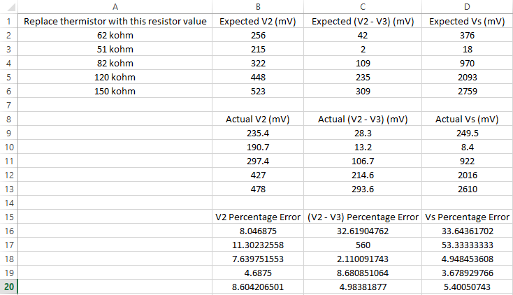

*Figure 4: shows the measurements at strategic locations when the thermistor was replaced with the above values. V2, V2-V3, Vs are the voltages indicated in the Therm12.xls file. V2 is the voltage drop from the positive terminal of the INA122P to ground. V2-V3 is the voltage drop from the positive terminal to negative terminal of the INA122P. Vs is the INA122P’s output voltage*

*Note: the huge percentage error in C17 and D17 is due to the fact that voltmeter isn’t accurate when reading such low voltages (it reads about 20 mV of noise when not connected to anything) (which makes those values recorded not really useable). Figure 5 indicates this.*

Voltage out when thermistor disconnected = 3.2 V

Voltage out when thermistor wires are shorted = 22 mV. This value is basically noise (as in zero volts).

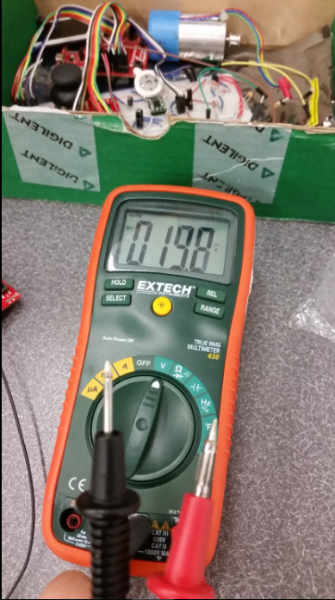

*Figure 5: shows voltage reading when not connected to anything (~20 mV of noise)*

* 1. **Dynamic Circuit Performance (Procedure 3)**

*Figure 6: For specific values, see Procedure3.xls. The gain starts to roll off around 10kHz and approaches one as frequency approaches infinity.*

*Figure 7: For specific values, see Procedure3.xls. The gain starts to roll off almost immediately and approaches one as frequency approaches infinity.*

* 1. **Accuracy (Procedure 6)**

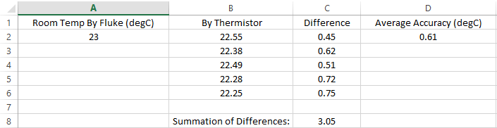

*Figure 8: The table above shows 5 measurements taken at room temperature. It shows the differences between our thermistor’s readings and our fluke meter’s readings as well as our average accuracy. The table shows that our values are, on average, within one degree of the “true” room temperature.*

* 1. **Reproducibility (Procedure 7)**

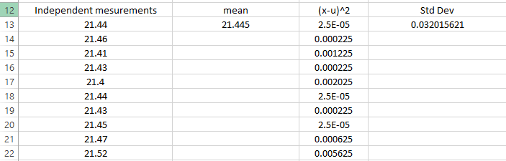

*Figure 9: The table above shows 10 measurements taken at room temperature (in a different room) and shows that our data is quite reproducible.*

1. **ANALYSIS AND DISCUSSION**
   1. **What is the Nyquist theorem and how does it apply to this lab?**

The Nyquist theorem states that in order to correctly represent an analog frequency in digital format, the signal must be sampled at a minimum of twice the frequency of the signal. The frequency of the temperature signal for this lab was between 0 and 10 Hz so we needed to sample it at least 20 times a second.

**5.2** **Explain the difference between resolution and accuracy?**

Resolution is the smallest change in temperature that the system can detect, while accuracy is the measure of difference between the actual temperature and temperature measured by the system.

**5.3** **Derive an equation to relate the thermometer’s reproducibility and precision.**

**5.4 What is the purpose of the LPF?**

To filter out high-frequency noise to the system and to prevent aliasing. Aliasing occurs when we try to sample frequencies greater than half our sampling rate, so we can remove those frequencies with a low pass filter.

**5.5 If the R versus T curve of the thermistor is so nonlinear, why does the voltage versus temperature curve look so linear?**

**5.6 There are four methods (a, b, c, d) listed in the Software Conversion section of methods and constraints. For one of the methods you did not implement, give reasons why your method is better, and give reasons why this alternative method would have been better.**

We used method d (small table lookup with linear interpolation in between). This method is better than using a large table lookup since it takes up less memory space, but has the tradeoff of being slower. A large table lookup would basically be a hash function with constant lookup time and zero collisions.

While using a nonlinear equation might be even more accurate than a large table lookup (since it fits the data better), it might not be a good choice considering the computation overhead of a linear equation (those exponentials, multiplications, and floating point numbers boil down to a lot more calculations than a simple linear interpolation involving slope and a few additions).